Homework #2: Descriptive Statistics: Central Tendency & Variability
Due (pushed back to Thursday Feb 5th)

Homework Hints: Please round all of your final answers to 2 decimals (e.g., 1.75, not 1.749). Round your final answers; rounding middle steps may result in inaccurate answers.

- Understanding measures of central tendency
  - Describe and explain the difference between the mean, median, and mode.
  - Generate your own example (neither from your book nor from lecture) in which the median would be the preferred measure of central tendency.

- Understanding measures measure of dispersion
  - Describe the concepts of the variance and standard deviation.
b. Explain why the standard deviation is more often used as a descriptive statistic than the variance; why might the standard deviation be more useful?

- A psychologist interested in political behavior measured the square footage of the desks in the offices of four U.S. Governors and four chief executive officers (CEOs) of major U.S. corporations. The measurements for the governors were 44, 36, 52, and 40 square feet. The measures for the CEOs were 32, 60, 48, and 36 square feet.
  - Calculate the means and standard deviations for both sets of scores.
  - Verbalize to yourself, in conceptual terms rather than computational terms, what you have just done.

- Describe and explain the location of the mean, mode, and median of a distribution of scores that is skewed strongly negatively.

- You calculate the variance of a distribution of scores to be -4.26. Why must this value be incorrect?

- The sum of individual deviations from the sample mean is equal to what value?

Homework #2:
Answers

- Understanding measures of central tendency
  - The mean, median, and mode for a normal distribution are all located at the same midpoint of the curve. This point is also the highest point in the distribution. In other words, this midpoint represents the most peaked point of the distribution. The mean, median, and mode then also describe the center of the distribution for a normal distribution equally well, however, the mean provides the most statistical information for describing the distribution. The mode is the highest point in the distribution because it is the most frequently occurring score and is located in the center of the distribution. This midpoint is also the median value which splits the distribution into two equal parts, above and below which 50% of the distribution falls. The mean also falls at the same point because the normal distribution is symmetrical around the midpoint and the mean is the mathematical fulcrum of the normal distribution.

- Understanding measures of dispersion
  - The mean is the average of a set of numbers; which represents the sum of the scores divided by the total number of scores. The mean is the most commonly used measure of central tendency because it accounts for every score in the distribution and does not very much from sample to sample. Specifically, the mean is less sensitive to sampling variation than are other measures of central tendency. The median represents the middle score of a distribution; the median is easy to identify when scores are organized from lowest to highest. The median is also sometimes used in lieu of the mean when outlying scores change the shape of the distribution to become skewed either positively or negatively. In such cases, the mean of the sample will not be the best measure of central tendency to describe the center of the distribution. Finally, the mode is the most commonly occurring value in a distribution; the mode is often used to analyze variables with a nominal scale of measurement.

  - One example of when the median would be the preferred measure of central tendency to represent a data set of equal-interval variables with an outlying score. A data set best represented by the median would be the following set of scores for the shoe sizes of 9-year-old boys: 5, 6, 6, 7, 7, 7, 7, 7, 8, and 15.

Variance and Standard Deviation

- The variance represents the average squared deviation of scores from the mean. The variance is calculated by squaring each score’s individual deviation from the mean, adding these squared values, and dividing by the total number of scores. 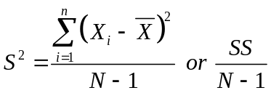. By extension, the standard deviation represents the average deviation of scores from the mean and is calculated by taking the square root of the variance.

- The standard deviation is more often used as a descriptive statistic than the variance because the standard deviation offers a more direct representation of the deviations from the mean; the deviations are not squared. In other words, when people talk about data, they talk about actual measured units (rather than squared units), the standard deviation is common parlance.

- Governor’s Desks vs. CEOs’ Desks

  - The mean for governors’ desks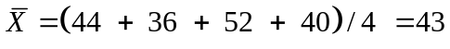 square feet
The mean for CEOs’ desks: 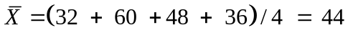 square feet

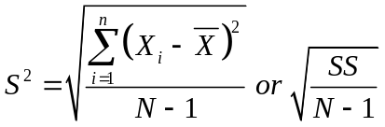

The standard deviation for governors’ desks:
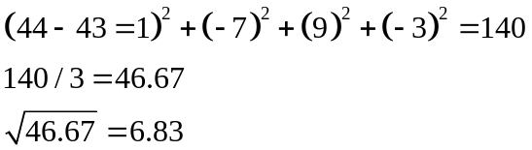

The standard deviation for CEOs’ desks:
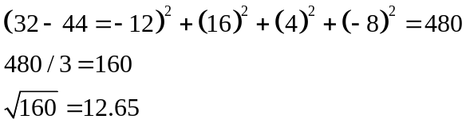

  - Although the means for the two samples are similar (e.g., 43 vs. 44 square feet), the standard deviation for the CEOs’ desks is nearly twice as much as for the governors’ desks. This means that there is a broader range of desk sizes among CEOs than among governors. In other words, governors’ desk sizes are more similar to each other than CEOs’ desks are similar to each other. This could potentially indicate that there is a greater range of incomes among CEOs than among governors, due to larger slush funds, etc.

- Location of Mean, Median, and Mode on Skewed Distribution
For a distribution of scores that is skewed strongly negatively, the mean would be much further to the left tail of the distribution than would either the median or the mode. This is because the calculation of the mean makes it sensitive to a single outlying score without having as large an impact on either the median or the mode. The mode would be located toward the right of the distribution and surrounded by most of the other scores because the mode is not affected by outliers (unless the extreme score were most common, but this would be rare). The median would be located between the mean and the mode; it would be located left of the mode because the median has to take account of the outlier and is affected by the outlier, but not to the extent the mean is affected by the outlier.

- Calculate a Negative Variance?

Calculating a negative variance measure must have occurred in error because the variance represents the average SQUARED deviation from the mean. All squared values have to be positive.

- The sum of all individual deviations from the mean is 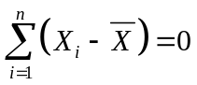. The mean serves as a fulcrum of the distribution that splits the distribution into two equal parts based on the magnitude of the scores and on the variability of the scores in the sample.

SPSS Assignment: Complete the procedures described on the next pages (Part 1 and Part 2) and then answer the questions. Although not required, it is best to replicate the SPSS printout to be sure you are conducting you analysis properly before answering other questions with SPSS.

Part 1.

- Open SPSS and save the file you create under the folder “Stats109” on your U:\drive. Create a folder on your McKenna Network drive, the U:\drive, and name it “Stats109”. You can save all of your stats work in this directory. We will access the data from this directory over the course of the semester.

- Create a data file in SPSS and enter the following data. Name your data file “HW2_Q2” and save it in your Stats109 folder so that you can locate it later if necessary.
Data: 2, 2, 0, 5, 1, 4, 1, 3, 0, 0, 1, 4, 4, 0, 1, 4, 3, 4, 2, 1, 0

- For full credit, make up a variable name to represent the set of numbers you entered. Also enter a variable label for the variable.

- Run the procedure Frequencies. This is found under the Analyze menu and then under Descriptive Statistics). Do not check any boxes in this frequency window yet. Press OK to run the Frequencies procedure. What type of frequency distribution does this procedure produce (ungrouped table, grouped table, bar chart, histogram, pie chart, etc.)?

Use Analyze → Descriptive Statistics → Frequencies to check over your data entry.

  - Click on Statistics (within the Frequencies option) to provide the measures of central tendency, variability, and shape (mean, median, mode, standard deviation, variance, skewness, and kurtosis).

  - Click on Charts (within the Frequencies option) and select histogram so that you can identify the shape of the distribution. Is the shape unimodal, bimodal, or multimodal? Is the graph skewed? If so, describe what the skew is and how you see skewness within the graph. Is the graph kurtotic? If so, describe what the kurtosis is and how you can determine kurtosis by within the graph.

- Print your output for these three procedures (frequencies, statistics, and charts) listed above.

Part 2.

- Open the SPSS data file named “Coronary artery data.sav” from your “Stats109” folder. Whenever you need to access data files while using SPSS, said files will be located in this “Stats109” folder on your U:\ Drive for easy access in the future.

- Looking at the variable view window in SPSS, what are the variable names (and variable labels, if applicable) and values (and value labels, if applicable) for both variables?

- What is the scale of measurement for each of these variables? (nominal, ordinal, equal-interval, etc.). Hint, SPSS calls equal-interval variables “scale” variables.

- Generate a histogram for time just as you did for the data in Part 1 of this assignment. How would you characterize the shape of the distribution for time?

- Print this histogram and attach it to your homework.
SPSS Part 1

For the following scores (2, 2, 0, 5, 1, 4, 1, 3, 0, 0, 1, 4, 4, 0, 1, 4, 3, 4, 2, 1, 0
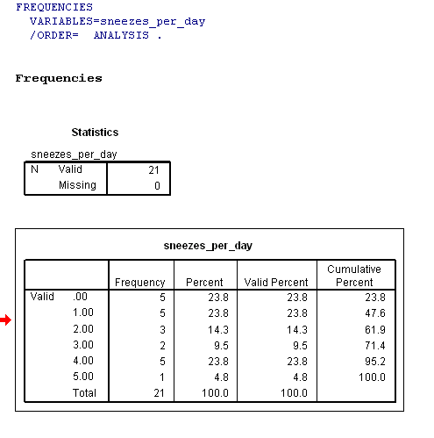

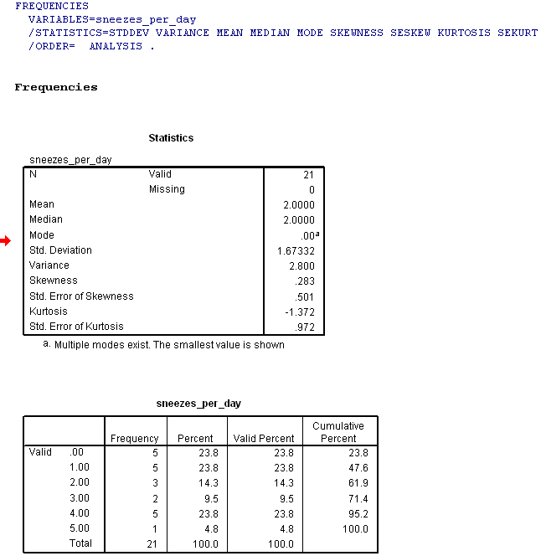

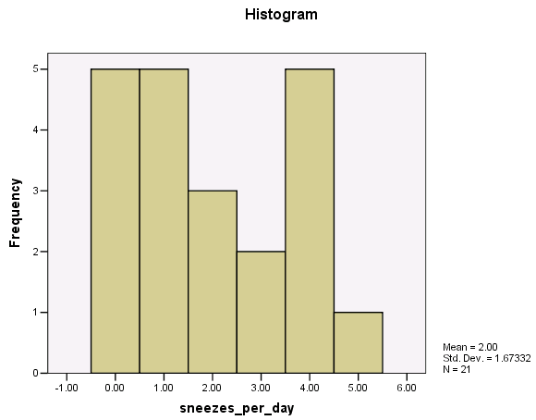
SPSS Part 2

Variable View

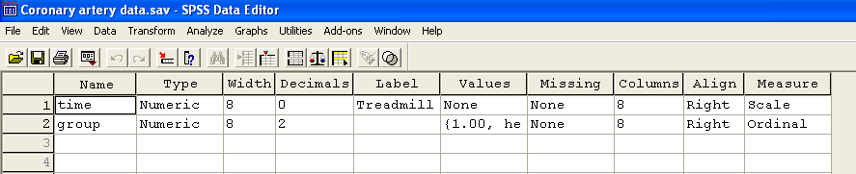

Histogram

